  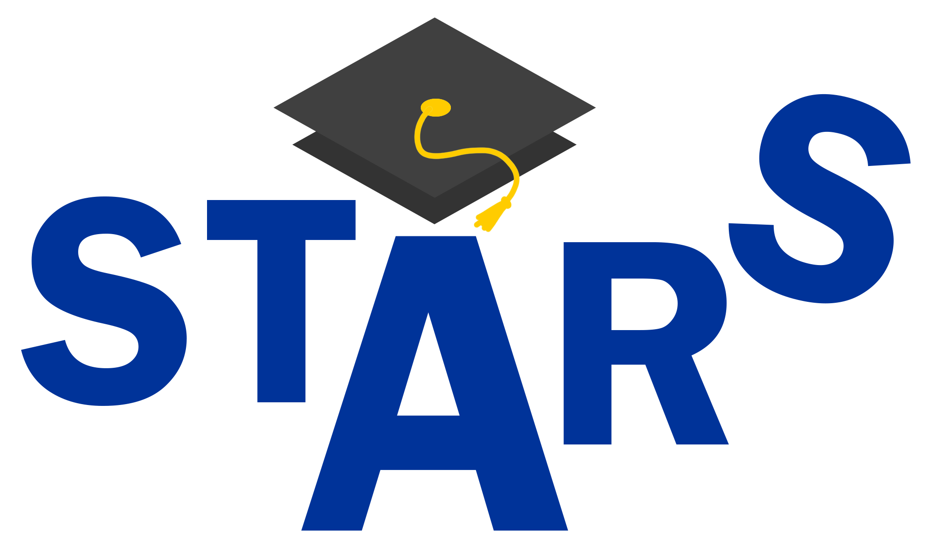 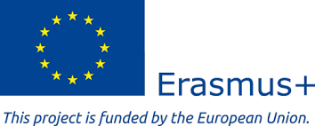

**STARS Winter School**

**Skills Transfers in Academia: A Renewed Strategy Enhancing Legal Clinics in the European Union**

**Accomplish a good team work skills in group assignments is considered one of the goals of the SSPLC.**

**So, in order to proceed, teams will be formed as follows:**

**TEAM 1: Phishing Case, Room A2**

**(Tutor: Matteo Ghisalberti)**

|  |  |  |  |
| --- | --- | --- | --- |
| Maria Victoria Dascălu   |  | | --- | | Kateřina Galdová  Camille Kohn | | Mirabela Savulescu | | Diana Urbášková | |
| **TEAM 2: Credit crunch Case, Room 11**  **(Tutor: Michela Mastrantonio; Damien Negre)**   |  | | --- | | Max Arend  Karolína Foukalová | | Domiziana Foti  Francesca Leali  Yang Qingya  Thongkhoon Yayyahong | |  | |  | |
| **TEAM 3: ATM Case, Room 12**  **(Tutor: Tommaso Sica)**  Zulaika Arapbaeva  Vanessa Battiato   |  | | --- | | Matěj Cetkovský | |
| Ana Maria Comoreanu  Maria-Georgiana Nechifor |
|  |
| |  | | --- | |  |   Be creative … Choose your names!! |
|  |
|  |